**Advance Excel Assignment 11**

1. Use the below table for the following Questions.

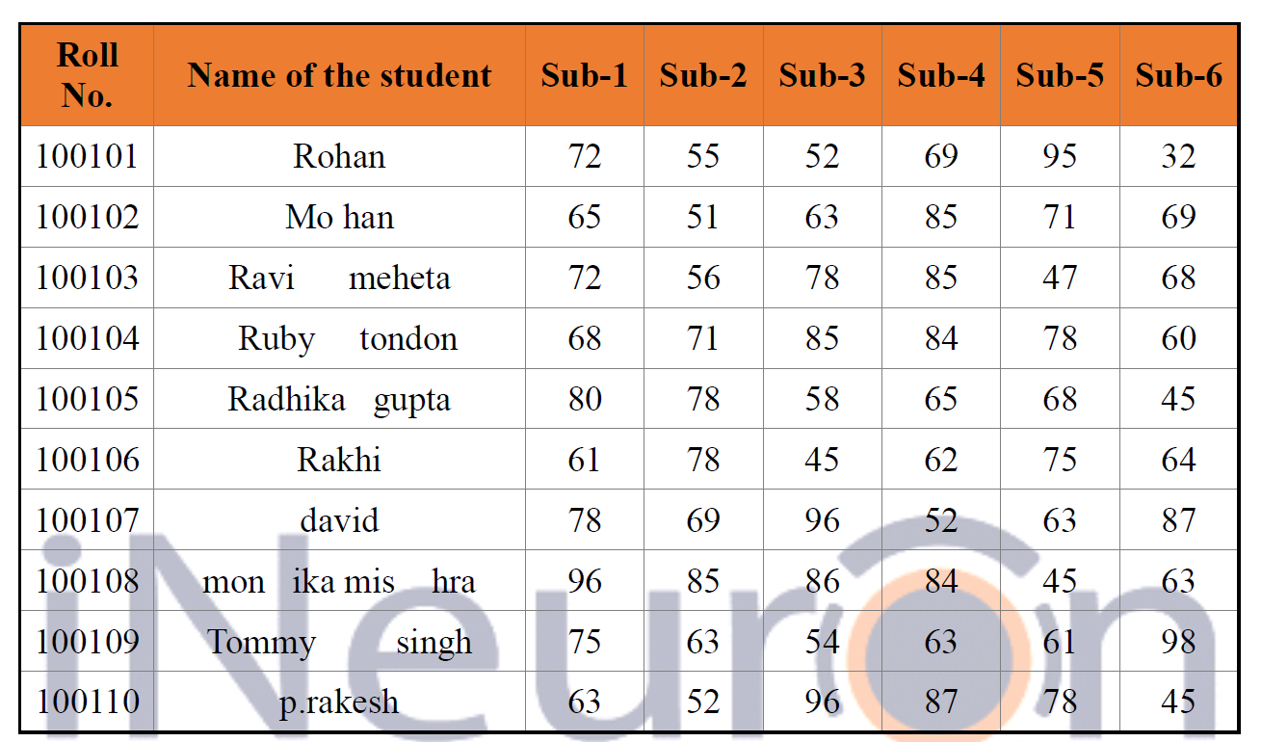

1. Find the Minimum Marks and Maximum marks scored by each student.

2. Calculate the totals for each student, use conditional formatting to highlight the top students who have scored more than 410.

3. Calculate the length of the names of each student.

4. Combine the Roll Numbers and Names. Use formulas. The end result should look like below.**

5. Replace the Name Rakhi with Rocky. Use Formulas

Ans.

